

ANDERSON REAL ESTATE
AI Growth & Integration Blueprint
EXECUTIVE SUMMARY

53  Properties | 3.1M  Sq ft · 9 markets | 250+  Tenants | $100M  Century City reposition

Prepared by Technijian · 2026-06-08 · for Rebecca Reyna, Chief of Staff

CONFIDENTIAL — Prepared exclusively for Anderson Real Estate

The Opportunity
The Opportunity

Anderson Real Estate is a family-owned commercial portfolio — 53 properties, 3.1 million square feet, 250+ tenants across nine markets — mid-way through a $100 million repositioning of its Anderson Towers campus in Century City, with Ares Management already signed as anchor. Century City is the top-performing office submarket on the West Coast, so the timing is excellent. The question is how AI helps the team capture that moment without losing the personal, relationship-driven service that is the family’s edge.
AI helps on two fronts, and they are different in kind. The first is leasing and tenant growth — winning the right tenants and holding the 250+ base — which is account-based and broker-driven, not a marketing funnel. The second, and the larger near-term return, is portfolio operations and efficiency — abstracting 250+ leases, automating CAM, and putting occupancy and rollover in one view — so a lean family-office team operates at an institutional standard.

Why Now
A single month of avoided vacancy on Century City office runs to six figures — faster, better-targeted leasing is the single largest number in the model.
Lease intelligence is the surest win: abstracting a complex lease takes a human 2–3 hours; AI does it in minutes — across 250+ leases that is one to two analysts of capacity recovered without new headcount.
Only ~5% of real-estate firms have made AI deliver. No Westside family owner-operator is known to have built this layer — Anderson can hold a genuine first-mover position.

How AI Helps — Two Fronts
How AI Helps — Two Fronts

The plan keeps the two fronts separate on purpose, because the right tool for one is the wrong tool for the other. AI is the operating layer under Anderson’s family-owned platform — it amplifies "people come first," it does not replace the relationship.

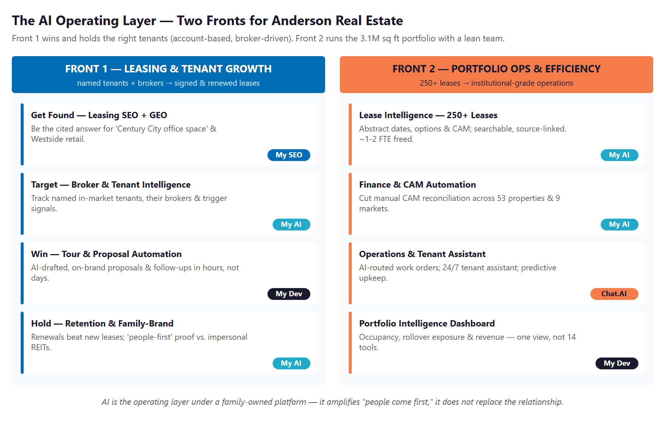
The AI operating layer: Front 1 wins and holds tenants; Front 2 runs the portfolio.

Front 1 — Leasing & Tenant Growth (account-based)
Be the cited answer for "Century City office space" and Westside retail; track named in-market tenants and their brokers; draft on-brand proposals in hours; tell the Ares-anchor story to court the next wave. Never broad "lead generation" — depth and timing against a known universe.

Front 2 — Portfolio Operations & Efficiency (the fastest return)
Abstract 250+ leases into a searchable, source-linked view; automate CAM across 53 properties; triage maintenance with a 24/7 tenant assistant; and put occupancy, rollover, and revenue in one live dashboard — one integrated layer, not 14 disconnected tools.

The Program — Start Small, Expand on Proof
The Program — Start Small, Expand on Proof

The program lands small and expands. The entry below is the headline ask — recurring quick-win services plus a lease-intelligence pilot and a free Nexus Assess, with no large build. The bigger build (portfolio dashboard, tenant portal, leasing CRM, full lease rollout) comes later, once the entry proves the lift.

Entry Program (Year 1) | Scope | Y1
My SEO — Leasing Visibility + GEO | AEO/GEO for Century City office & Westside retail | $15,000
My AI — Lease-Intelligence Pilot + Advisor | Abstract a first lease tranche + AI roadmap | $30,000
My AI — Executive AI Workshop | Leadership session to prioritize the roadmap | $5,000
Nexus Assess — Risk Scan | Free, no-commitment IT/security assessment | $0
ENTRY PROGRAM — the easy yes | No large build to begin | ~$50,000

Modeled against that small entry, the return is strong and honest (all figures estimated, conservative, and calibrated on a discovery call):
Year-1 Value at Stake | Downside-Protected | Likely | Upside
Total value attributed | $75,000 | $215,000 | $410,000
Technijian ENTRY investment | ~$50,000 | ~$50,000 | ~$50,000
Modeled ROI vs. entry | 1.5× | 4.3× | 8.2×

Roadmap & Next Step
Roadmap & Next Step

A 90 / 180 / 365-day cadence, sequenced land-first: prove the lease-intelligence win and switch on leasing visibility, then build the account-based leasing engine, then the portfolio intelligence layer and scale.

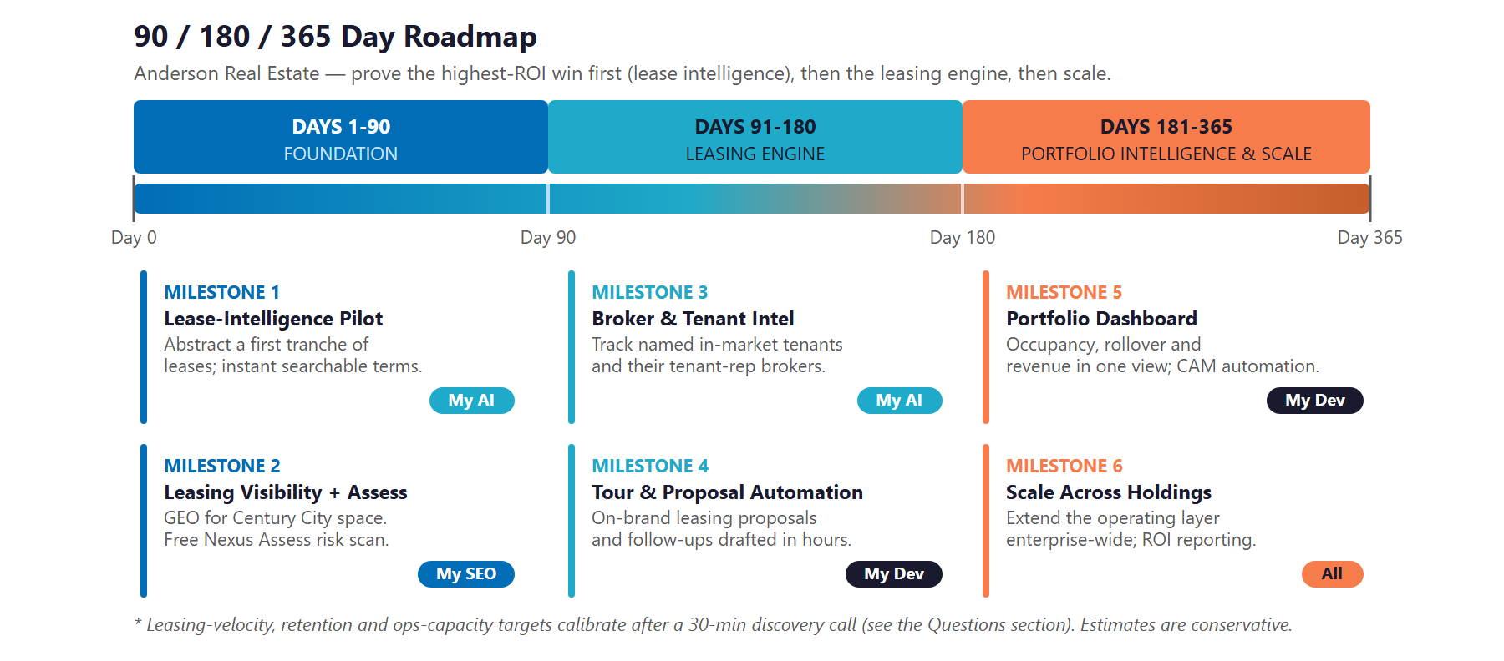
90 / 180 / 365-Day Roadmap — prove the highest-ROI win first, then the engine, then scale.

A 30-minute conversation is the next step.
We can run the free Nexus Assess in parallel, and return a calibrated ROI model and fixed-scope plan within 5 business days.
Ravi Jain, Founder & CEO · rjain@technijian.com · 949.379.8499 · technijian.com

The full 25-page plan — personas, competitive landscape, capability proof, both fronts in detail, and the complete investment map — is ready on request.

